KZN DEPARTMENT OF EDUCATION

**INFORMATION TECHNOLOGY**

**GRADE 10**

**PAPER 2**

JUNE EXAM 2017

**Duration : 2 hours Max Mark : 100**

**INSTRUCTIONS AND INFORMATION**

1. This question paper consists of **SIX** Questions:

QUESTION 1 : Multiple-choice Questions (10)

QUESTION 2 : Matching (10)

QUESTION 3 : System Technologies- Hardware (23)

QUESTION 4 : System Technologies : Software (12)

QUESTION 5 : Solution Development (20)

QUESTION 6 : Integrated Scenario (25)

|  |  |  |  |
| --- | --- | --- | --- |
|  | Answer ALL the questions. |  |  |

|  |  |  |  |
| --- | --- | --- | --- |
|  | Read ALL the questions carefully. |  |  |

|  |  |  |  |
| --- | --- | --- | --- |
|  | The mark allocation generally gives an indication of the number of facts required in your answer. |  |  |

|  |  |  |  |
| --- | --- | --- | --- |
|  | Number the answers correctly according to the numbering system used in this question paper. |  |  |

|  |  |  |  |
| --- | --- | --- | --- |
|  | Write neatly and legibly. |  |  |

**SECTION A**

|  |  |  |
| --- | --- | --- |
| QUESTION 1: MULTIPLE-CHOICE QUESTIONS (10) |  |  |

|  |  |  |
| --- | --- | --- |
| Various options are given as possible answers to the following questions. Choose the answer and write only the letter (A–D) next to the question number (1.1–1.10) in the ANSWER BOOK. |  |  |

1.1. Which of the following is an example of system software?

1. Microsoft Word
2. Adobe Photoshop
3. Linux
4. iMovie (1)

1.2. Which of the following is NOT an output device?

1. printer
2. speaker
3. monitor
4. touchpad (1)

1.3. Which of the following is a characteristic of RAM?

1. Cheap
2. Stores information when the PC is off
3. Volatile
4. Data transfer is slow (1)

1.4. Which of the following is not part of mechanical storage?

1. CD
2. HDD
3. SSD
4. Blu-ray (1)

1.5. A file extension for a Delphi project file.

1. .proj
2. .dcu
3. .unit
4. .jpeg (1)

1.6. Specification NOT necessary to consider when purchasing a new monitor.

1. Resolution
2. Capacity
3. Response time
4. Contrast ratio (1)

1.7. The functions of an operating system does NOT include…

1. Word processing
2. Process and task management
3. Memory management
4. Providing an interface (1)

1.8. Which of the following is an example of a Utility program?

1. iCloud
2. Dropbox
3. OneDrive
4. Disk Clean-up (1)

1.9. Which one of the following is an example of both an input and an output device?

A. Touch pad

B. Keyboard

C. Scanner

D. Touch screen (1)

1.10. Windows explorer has the following function…

1. To browse the internet
2. Makes a backup of files
3. Used to check for new viruses
4. To manage files and folders (1)

**QUESTION 2: MATCH THE CORRECT TERM(10)**

# Choose the correct description from Column B that matches the terms in Column A and write only the letter next to the question number (2.1. – 2.5.) in the ANSWER BOOK. E.g. 2.6. K.

|  |  |
| --- | --- |
| **Column A - TERMS** | **Column B – DESCRIPTION** |
| 2.1. Carpal Tunnel Syndrome | A. Software that can be modified |
| 2.2. Proprietary software | B. Type of mechanical storage |
| 2.3. Solid State Drive | C. Study and design for comfort and safety in work  environments |
| 2.4. Peripheral | D. Pressure in the nerves of the wrist |
| 2.5. Ergonomics | E. Type of electronic storage |
|  | F. Software owned by a company |
|  | G. Devices that connect to a computer via a port |

(5x2) = 10

**TOTAL: SECTION A (20)**

# SECTION B

# Scenario

The local library needs to upgrade their Computer Centre. RandSaver Stores were willing to sponsor an upgrade to the value of R50 000. The management members of the library have called on the Information Technology learners at a local Secondary School to assist in the selection of the computers for the centre. You are part of the team of learners who will be assisting with queries and questions.

**QUESTION 3 : System Technologies: Hardware [23]**

The learners have selected the computer below.

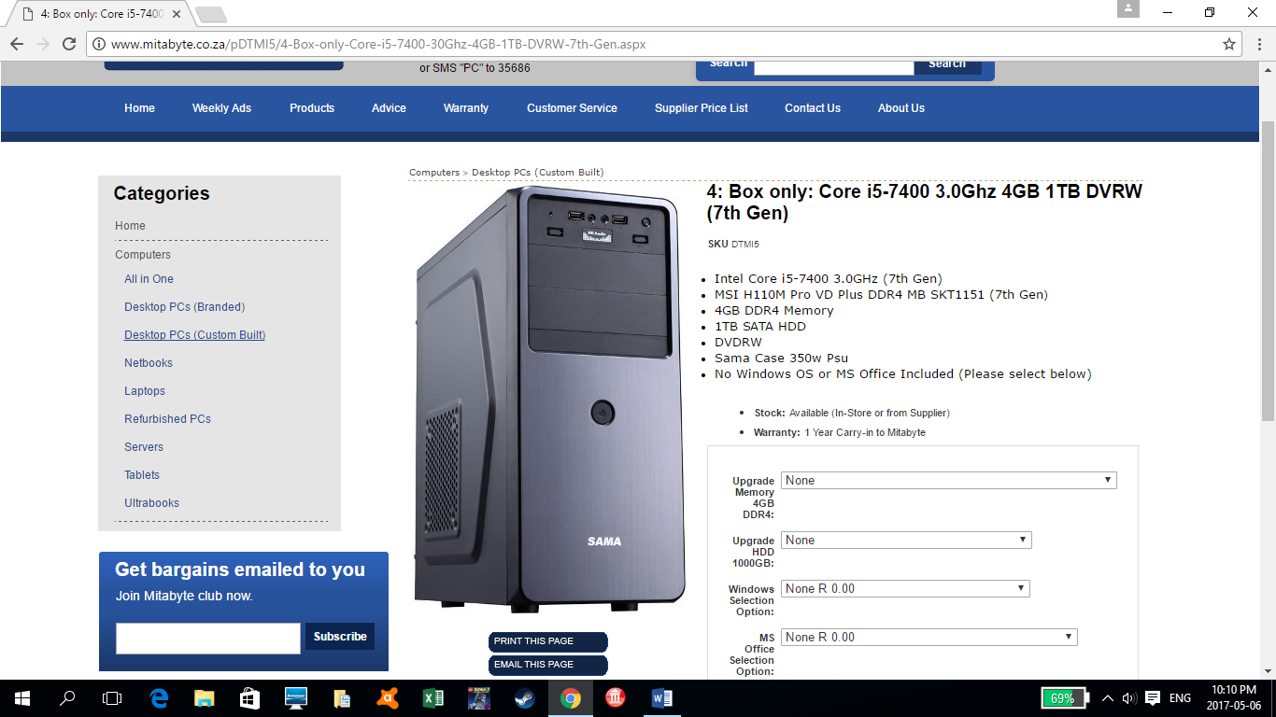

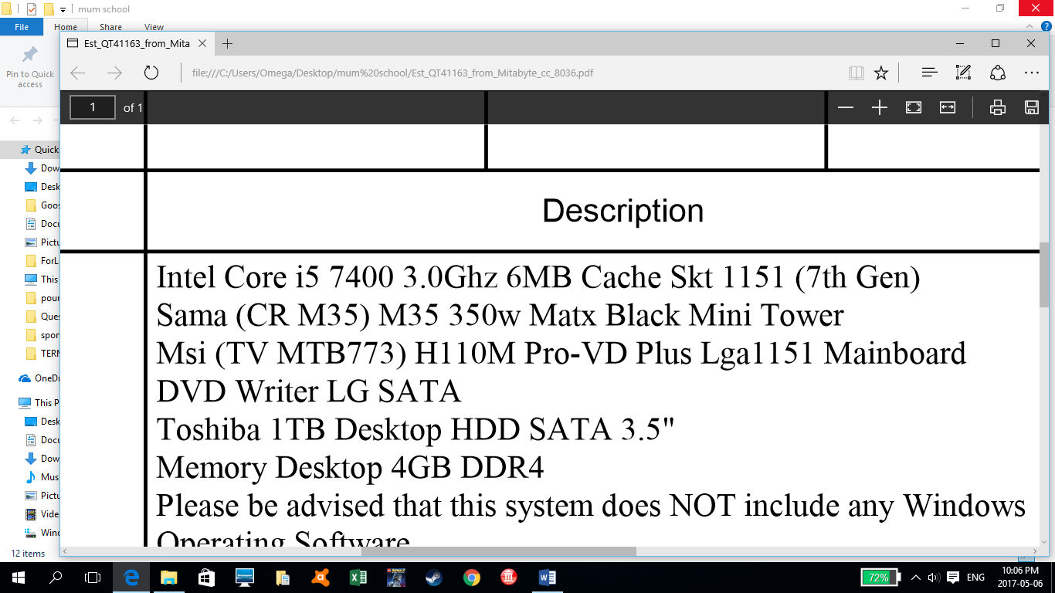

**Answer the following questions related to the quote and the hardware of the computer.**

3.1 What is the speed of the CPU? (1)  
3.2 A computer tower will contain a fan. Why is this necessary? (2)  
3.3 State the size of RAM that the computer has. (1)  
3.4 Explain what 1TB HDD refers to? (2)  
3.5 The computer will have six USB ports. What is the reason for many USB   
 ports? (1)  
3.6 A mouse is essential. State another common input device. (1)  
3.7 What is the function of RAM in a computer. (1)  
3.8 The team has to select a screen for the computer. An 18.5” will be suitable.  
3.8.1 What does 18.5” mean? (1)  
3.8.2 Explain how the size of a screen is measured. (1)  
3.9 From the quote give an example of a/an:  
3.9.1 Magnetic storage device (1)  
3.9.2 Optical storage device (1)

3.10 What is the purpose of a firewire port? (1)

3.11 The quote comes with an MSI motherboard. State TWO functions of a  
 motherboard. (2)

3.12 The librarian wants to include a scanner and printer in the purchase.

You suggest purchasing a multifunction printer.

3.12.1 List TWO other functions besides printing that a multifunction printer

provides. (2)

3.12.2 Explain why a multifunction printer is beneficial when compared to

purchasing a separate scanner and a printer. (1)

3.13 The librarian would like know if a biometric scanner will benefit users of the computers. Explain why users of the computer will not require a biometric scanner by discussing the purpose of a biometric scanner. (2)

3.14 State TWO advantages of using a flash-drive to store data instead of a DVD.  
 (2)  
 **[23]**

**QUESTION 4 :System Technologies: Software [12]**

The computer system does not come with software as the library has licensed software

which includes **Windows 10, Microsoft Office 2016 and Norton Antivirus.**

4.1 State from the above mentioned software which is an:

4.1.1 Operating system (1)  
4.1.2 Application software (1)

4.2 Why is operating system essential software? (1)

4.3 Give an example of utility software. (1)

4.4 With a new multifunction printer, a device driver must be installed.

4.4.1 State the purpose of a device driver. (1) 4.4.2 Where can the device driver be obtained from? (1)

4.5 Windows 10 has a GUI (Graphical User Interface). Explain what a GUI is. (1)

4.6The librarian would like to know more about compression software.

4.6.1 Give an example of compression software. (1)  
4.6.2 Discuss the purpose of compression software. (2)

4.7 The operating system is responsible for memory management. Explain what memory management involves. (2)  
 **[12]**

**TOTAL: SECTION B** **(35)**

**SECTION C**

**QUESTION FIVE [Solution Development]**

***Information technology learners are subjected to a process of debugging and testing during software design. One of the tools used to achieve this process is called a trace table. Study the algorithm given below and answer the questions based on it.***

Line No.

1. Input (num) - user enters an integer

2. c1 🡨 1

3. c2 🡨 2

4. Loop i from 1 to num

5. Input (number) - user enters an integer

6. if number mod i = 0 then

7. c1🡨c1+ 1

8. else

9. c2🡨c2+1

10. Display c1

11. Display c2

5.1. Use the headings given below to draw up a trace table in your answer books.

Show a complete trace of the code above on the trace table for the input   
 value num = **5** and number =  **6 4 3 2 9.**

(7)

N.B. Start your trace table on a new page so that you will have enough   
 space if necessary.

|  |  |  |  |  |  |  |  |
| --- | --- | --- | --- | --- | --- | --- | --- |
| **Line No.** | **Num** | **i** | **number** | **Num mod i = 0 ?** | **C1** | **C2** | **Display/Output** |

5.3. State briefly what this algorithm is designed to do. (2)

5.4. Write an algorithm to enter 30 marks. Calculate and display the highest and the

average mark. (7)

5.5 Convert the following to the required base.

5.5.1 F45**16** to Decimal (3)

5.5.2 359 to Octal (3)

[22]

**QUESTION SIX [Integrated Scenario]**

6.1 *The management is concerned about the employees spending prolonged periods*

*of time in front of the computers as he has heard that computers can have an*

*adverse effect on their health.*

6.1.1 List TWO ways in which computers can possibly contribute to ill health. (2)

6.1.2 List TWO common-sense, practical precautions that you could take to

prevent your health being adversely affected by the prolonged use of a

computer. (2)

6.2 *Many users who come to the computer centre have difficulty in using the*

*Computers and other electronic devices.*

6.2.1 What does Digital Divide refer to? (2)

6.2.2 List and explain TWO factors that contribute to the digital divide. (2)

6.3.1 Explain what software piracy is. (2)

6.3.2 State 2 examples of software piracy. (2)

*6.4 To reduce costs the management wanted to explore the use of “free”*

*software and have heard about freeware, shareware and open source software.*

6.4.1 Briefly explain the difference between freeware and shareware software. (4)

6.4.2 Rather than purchase a copy of Microsoft Office, the Library Management   
 wants to know about using “**open office**”

1. Which one of the three categories (below) does ***open office*** fall into? (Freeware/Shareware/Open source) (1)
2. In order to advise the library management, state 2 advantages and 1 disadvantage of using open office instead of MS Office. (3)

*6.5 The Library Managers wants as far as possible to reduce the negative*

*impact the new library centre will have on the environment.*

6.5.1 Name the term used to describe the environmentally responsible and   
 eco-friendly use of **computers** and their resources? (1)

6.5.2 Name TWO ways in which the new centre can help reduce their carbon  
 footprint and be environmentally friendly. (2)

[23]

**TOTAL: SECTION C (45)**

TOTAL:100